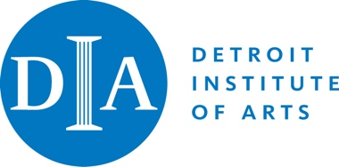

Statement from Eugene A. Gargaro, Jr.
Chair, Detroit Institute of Arts Board of Directors

March 29, 2021 -- During the past two weeks and following the release of a recording of a confidential Board meeting held last November, I have engaged in constructive and candid discussions to develop a consensus in a fair and reasoned manner to identify and recommend solutions to the serious issues the Board is currently addressing, while the Board’s Executive Committee meets regularly. The DIA’s board is composed of 54 elected board members, 32 emeritus members and 44 honorary members. I have spoken with every Executive Committee member and many other Directors as we work toward agreement on how to solve serious internal concerns facing the museum. During this period, the Executive Committee has met twice and discussed the situation in detail.

At an Executive Committee meeting on Friday, March 26, a consensus favored continuing the actions taken by the Board late last year, including frequent monitoring and reporting on progress to the Executive Committee and the Board. Some members disagreed and decided to resign from the Board. They are: Anne Fredericks, Mary Ann Gorlin, Julie Rothstein, Suzanne Shank, Carol Walters and Celeste Watkins-Hayes. Emeritus Director Marc Schwartz has also resigned with similar concerns. Additionally and coincidentally, Christine Sitek chose to leave the Board because of professional obligations.

I thank each of these Directors for their service and support and am sorry that these resignations have occurred. I wish that they all would have remained and continued to work with us to help the DIA reach its full potential. I am confident that our Board members will continue to provide critical input and productive involvement as we work together in shaping the future of the DIA.

