AI-DA ROBOT ANNOUNCES FIRST EXHIBITION DURING THE
59TH INTERNATIONAL ART EXHIBITION OF LA BIENNALE DI VENEZIA

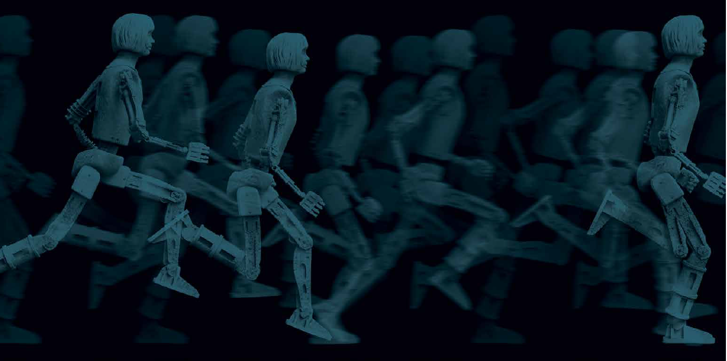

AI-DA ROBOT
LEAPING INTO THE METAVERSE

CONCILIO EUROPEO DELL'ARTE, GIARDINI, VENICE

EXHIBITION 23RD APRIL – 3RD JULY 2022
PRESS PREVIEW 19TH APRIL

On 23rd April 2022, Ai-Da Robot, the world’s first ultra-realistic humanoid robot artist, will open a major contemporary art exhibition in Venice’s famous Giardini area during the 59th International Art Exhibition – La Biennale di Venezia.

While robot artworks have been exhibited during La Biennale di Venezia in previous years, 2022 will mark the first time an ultra-realistic humanoid robot artist presents a solo exhibition of artworks during La Biennale di Venezia as a human artist would.

Titled Leaping into the Metaverse, Ai-Da Robot’s exhibition will take place at the Concilio Europeo Dell'Arte venue, InParadiso Gallery in the focal Giardini. Presented over five connected spaces, the exhibition will explore the interface between human experience and AI technology, from Alan Turing to the Metaverse, and will draw on Dante’s concepts of Purgatory and Hell to explore the future of humanity in a world where AI technology continues to encroach on everyday human life.

As a robot artist Ai-Da poses two questions: who are we, and what is art? We are in the midst of an AI explosion and AI is already deeply embedded in our way of life - when we shop, when we interact with companies and institutions and soon with the coming Metaverse. Ai-Da’s unsettling human resemblance challenges us to consider how far we are willing to accept AI in our lives.

“This is an important moment for AI art, Ai-Da’s works raise questions about whether robots can genuinely be creative,” Priya Khanchandani, Head of Curatorial at The Design Museum, London.

In 2019 Ai-Da Robot made history at Oxford University as the world’s first ultra-realistic humanoid robot capable of drawing people from life using the cameras in her eyes, her AI algorithms, and a pencil in her robotic hand.

In 2021 Ai-Da Robot made history a second time at London’s The Design Museum as the first ultra-realistic humanoid robot to create a self-portrait. A robot with no-self creating a self-portrait challenges our understanding of what it means to be human and how AI is changing us.

In 2022 Ai-Da Robot’s latest ground-breaking development will be premiered during La Biennale di Venezia. Ai-Da will present a new cutting-edge painting arm that uses advanced AI algorithms and robotics, enabling Ai-DA to paint from life using a colour pallet as human artists have for centuries.

This astonishing new painting ability will be exclusively premiered by Ai-Da Robot during the 59th International Art Exhibition – La Biennale di Venezia, painting four portraits throughout the vernissage week in front of a live audience. These works will go on to form part of the exhibition.

“Human characteristics could never be imitated by a machine…such attempts and their results would have something like the unpleasant quality of artificial flowers.” Alan Turing

Entering the exhibition visitors will be confronted by Flowers on the banks of the Lethe, an artwork made up of 3D printed flowers created from Ai-Da’s sketches using AI algorithms. This installation of artificial flowers replicates the flower strewn banks of the mythical river Lethe - the river of forgetfulness as described in Dante’s Divine Comedy (Purgatorio XXVIII-XXX). The artwork can be seen as a response to Alan Turing’s thoughts on artificial humanoids and encourages us to consider the role of artificiality in our lives and futures.

Alan Turing expressed both promise and disappointment in the act of creating artificial androids, comparing humanoid endeavours as ‘something like the unpleasant quality of artificial flowers’, while suggesting that a thinking machine ‘will help us greatly in finding out how we think ourselves.’

The exhibition continues with a series of glass artworks, first exhibited at the V&A Museum, that draw on the pioneering photographic studies made by Eadweard Muybridge. Titled Leaping into the Metaverse, each artwork is a scanned image of Ai-Da’s agile robotic form leaping into the Metaverse, a place which many people will enter with their own digital avatars and VR personas – but at what cost?

“Only photography has been able to divide human life into a series of moments, each of them has the value of a complete existence.” Eadweard Muybridge

Moving further into the exhibition, Ai-Da’s artworks use Dante’s Purgatorio to confront our fears about the Metaverse. In Purgatorio the Fortune Tellers and Diviners are the souls who, on Earth, tried to see too far ahead of them. With their heads fixed on backwards and their eyes full of tears, they are destined to spend eternity looking behind with blurred vision.

Parodying Dante’s Fortune Tellers and Diviners, Ai-Da robot appears as a hologram titled Magical Avatars: Ai-Da Goes Holographic with her head facing the opposite way to her torso. This new work reflects the darker side of both the digital world as well as Metaverse. Just as Purgatory is a halfway house between Heaven and Hell, the Metaverse is neither reality nor fiction – but a middle ground where the line between fiction and reality becomes blurred.

In the same way that Dante urges us to contemplate the subtle yet powerful transformations in the way we ‘see’ others in the Divine Comedy, Ai-Da’s Venice exhibition Leaping into the Metaverse, urges visitors to do the same. Ai-Da cannot see as humans do, yet her artworks encourage us not to lose sight of others, even while the world is changing rapidly and deeper truths are obscured by the growing power of technology.

A series of artworks titled Eyes Sewn Shut, including 8ft high canvases, feature Ai-Da’s response to Dante’s Circle of the Envious (Purgatorio XIII). Ai-Da has no life or sight: she embodies the blindness of technological advance if pursued at the expense of true regard for others. In these works, Ai-Da paints portraits of herself with her eyes sewn shut, influenced by Dante’s striking imagery for this Canto.

The exhibition includes several sculptural artworks, the largest of which is a work titled Immortal Riddle. Created collaboratively with her AI informed design, drawings and clay impressions, it plays on the ancient Egyptian considerations of the afterlife and our current obsession with using biotechnology to achieve immortality in the 21st century. At a time when biotechnological interventions are starting to act directly on the human body, Ai-Da appears in sculptural form with three robotic legs – a play on the riddle of Sophocles’ Sphinx. In this artwork, through her uncanny and awkwardly altered anatomy, Ai-Da encourages us to consider whether a world of such overt mechanical and biological intervention is something we really want.

When Immortal Riddle was first shown at the Great Pyramids in Egypt in 2022, it caused an international scandal. Ai-Da was seized by Egyptian boarder guards, suspected of holding spy technology. Ai-Da and her artworks were detained for 10 days before being allowed to take part in the exhibition. The actions of the Egyptian authorities clearly reflect wider international security concerns around technology.

TITLE: LEAPING INTO THE METAVERSE
CURATOR: AIDAN MELLER
EXHIBITOR: AI-DA ROBOT
VENUE: CONCILIO EUROPEO DELL'ARTE, GIARDINI VENICE
PRODUCER: Halime Özdemir
WEBSITE: https://www.ai-darobot.com/

PRESS PACK: https://www.dropbox.com/sh/56zhpuaxg6m6tuz/AABBMBdLvloMeKKlVk8Fq-S9a?dl=0
PRESS CONTACTS:
Tory Lyne-Pirkis at MIDAS tory.lyne-pirkis@midaspr.co.uk +44 7766 5503 053
Suzie Jacobs at MIDAS Suzie.Jacobs@midaspr.co.uk
Kat Daly at MIDAS Kat.Daly@midaspr.co.uk
PRESS PREVIEW DAYS: 19, 20, 21, 22 April 2022
EXHIBITION DATES: 23rd April – 3rd July 2022

Ai-Da’s presentation at Venice, follows a raft of high profile exhibitions over the past two years including participating in Forever is Now 2021, the first major contemporary art exhibition at the great Pyramids of Giza in Egypt, and the London Design Festival 2021 at the V&A Museum where Ai-Da showed some of the first ever Metaverse works at a major art institution.

Since her first solo exhibition Unsecured Futures’ at the University of Oxford in 2019, Ai-Da has presented a world-first Self Portrait solo show at The Design Museum London, been part of the United Nations group exhibition ‘WIPO: AI and IP, A Virtual Experience’, featured in the pop band The 1975’s art video Yeah I Know, collaborated with artist Sadie Clayton on a series of workshops titled Exploring Identity Through Technology at Tate Modern, given a TEDx talk at the University of Oxford and featured in the BBC documentary Kazuo Ishiguro: Remembering and Forgetting. In 2021 Ai-Da had an artistic residency at the iconic Porthmeor Studios in St Ives, the home of the St Ives artists who changed the course of modern art and sculpture. In September 2021 Ai-Da exhibited at The Ashmolean Museum to celebrate 700 years of Dante.

Press Response to Ai-Da Robot:
“A new voice to the art world” The New York Times
“A contemporary art project that aims to prompt debate about the rapid rise of artificial intelligence technology.” The Guardian
“…blurs the boundary between machine and artist; a vision of the future suddenly becoming part of our present” TIME Magazine
“…every bit as good as many of the abstract working artists today” The Daily Telegraph
“A Robot with its art in the right place” The Times
“The new Picasso” i Newspaper

About Ai-Da Robot

Ai-Da is the world’s first ultra-realistic robot artist, named after Ada Lovelace, the first computer programmer of all time. As a machine, with Artificial Intelligence capabilities, her artist persona is part of the artwork, along with her drawings, performance art and collaborative paintings, sculptures and for the first time in 2022 her new paintings. As a work of conceptual art, Ai-Da encourages us to re-consider our self-perception through the lens of a humanoid. Her persona blurs the lines between human and machine interactions, providing an acutely relevant reflection on current societal trends.

Ai-Da was devised in Oxford by Aidan Meller (UK), built in Cornwall by Engineered Arts (UK), and programmed internationally. Her drawing arm and her drawing AI algorithms were designed by Salaheldin Al Abd and Ziad Abass, (Egypt). Her additional AI capabilities come from PHD students and professors at the Universities of Oxford and Birmingham.

In 2020 she gave a TEDx talk and exhibited work at the United Nations exhibition ‘WIPO: AI and IP, A Virtual Experience’. Highlights of 2019 include her first show ‘Unsecured Futures’ at the University of Oxford, being part of European ARTificial Intelligence Lab exhibition at Ars Electronica, Linz, and a workshop at the Tate Exchange, Tate Modern, London. In December 2019 she was interviewed by Tim Marlow (artistic director of the Royal Academy) at the Sarabande Foundation, London.

About Aidan Meller

Ai-Da was devised by Aidan Meller - a specialist in modern and contemporary art. The Creative Director and Project leader for Ai-Da Robot, Aidan has over 20 years’ experience in the art world. It was while reading and seeing how technology is disrupting large sections of society, that he realised the need to discuss these shifts in society. Focusing on AI and robotics, Aidan devised Ai-Da as an entity that would be able to challenge the morphing world of trans-humanism. Meller says: “The greatest artists in history grappled with their period of time, and both celebrated and questioned society’s shifts. Ai-Da Robot as technology, is the perfect artist today to discuss the current obsession with technology and its unfolding legacy. Is the so called ‘progress’ in technology something we really want, and if so, how should it manifest?”

