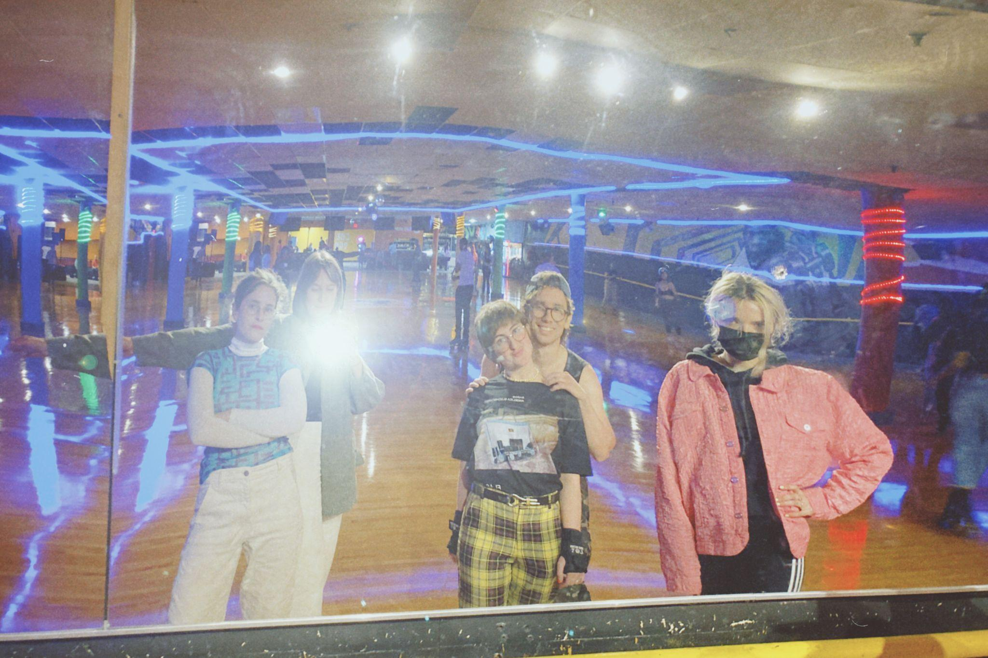
My friends always joke that I'm Boston's biggest cheerleader. I don't really know how it happened. I didn't grow up here, but I went here for school then stuck around long enough to start an art magazine with a pretentious title. I guess I feel like if I could find the parts of Boston that are totally lovable, then everyone should. A place that I love is Chez Vous—a skate park in Dorchester that's been operating for over 80 years. My friend (and brilliant writer / resident NFT expert) Josie Thaddeus-Johns is currently leading the rollerskating charge in my Cambridge friend group and dragged us away from my computer on a Wednesday night to hit the rink.

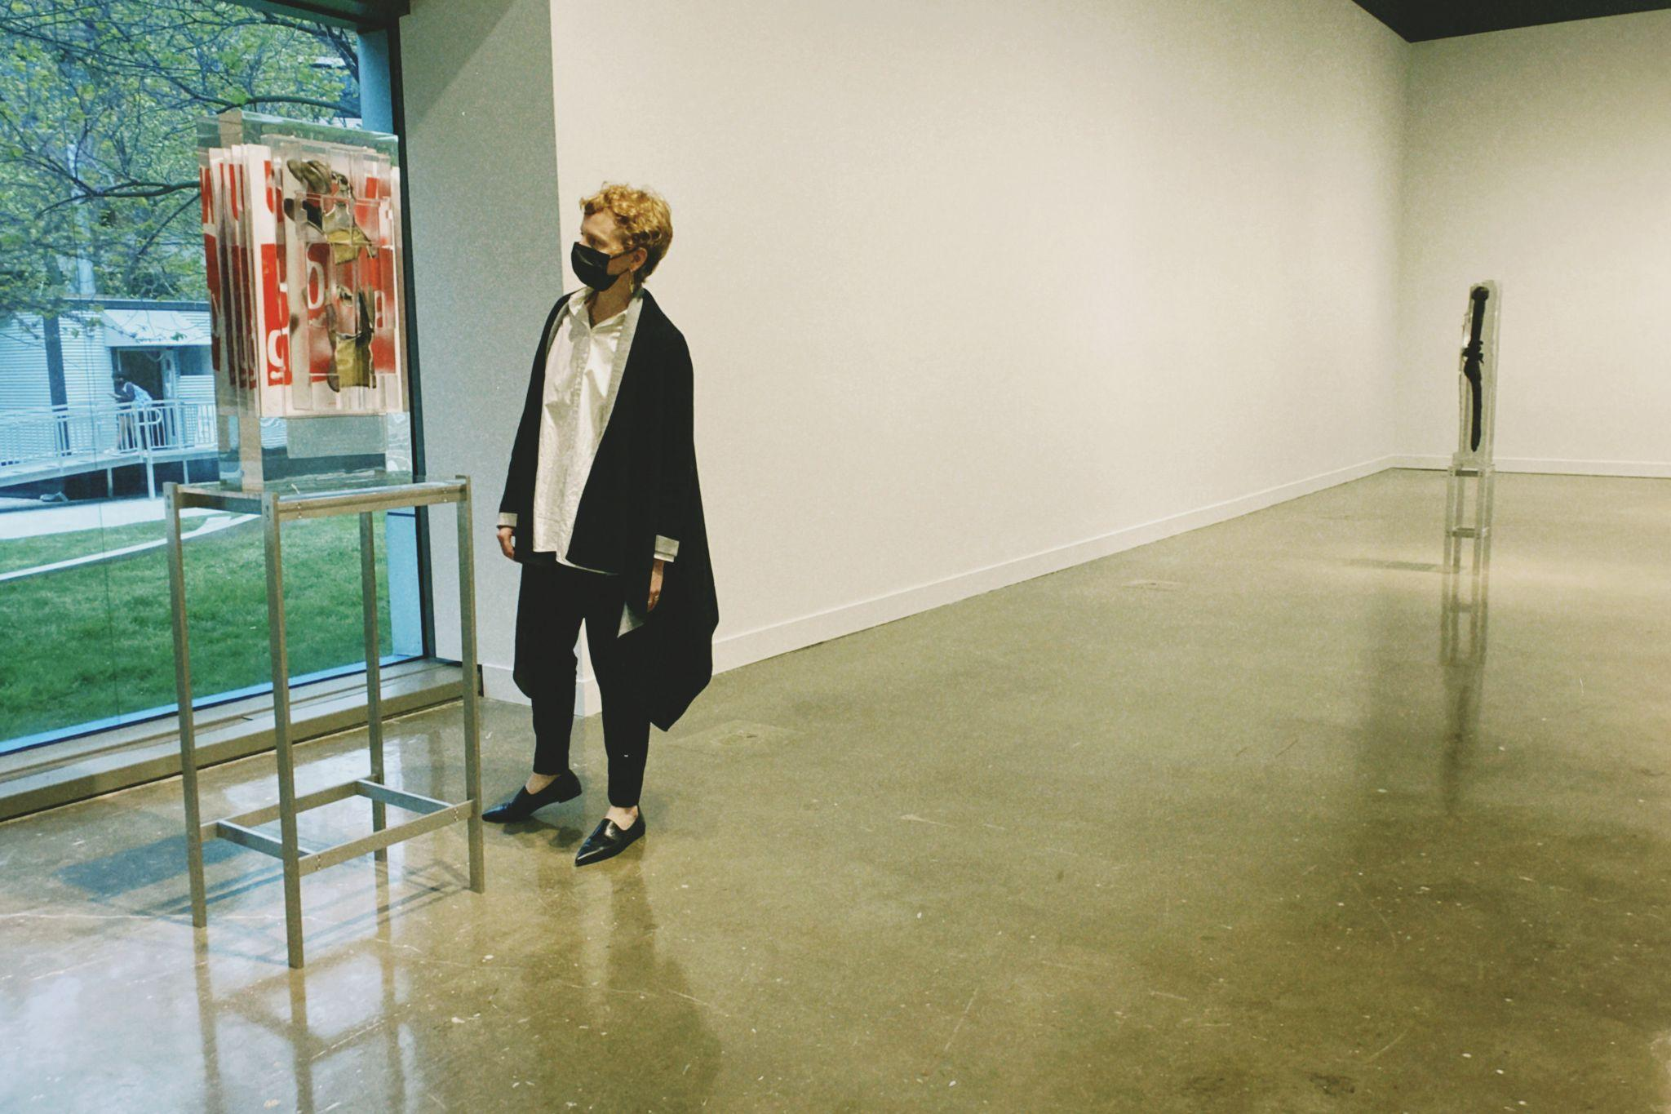
My days are spent primarily at the MIT List Visual Arts Center where I manage communications. Natalie Bell (pictured here next to work by Matthew Angelo Harrison) and Selby Nimrod (pictured in pink jacket at the roller rink) are at the helm of our curatorial programming and office outfit trendsetting.
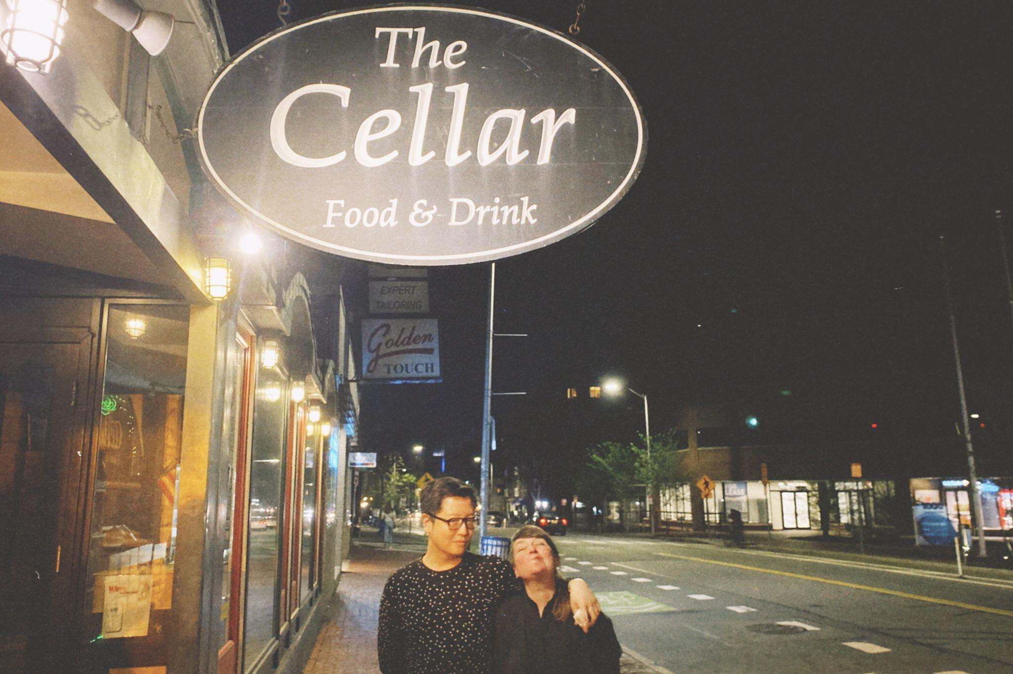
On occasional weeknights, artist and Harvard professor Katarina Burin rallies local and visiting colleagues to gather for a drink. She calls the gatherings "Stammtisch" which is the German word for a "regulars table." I think this means I'm a regular. There wasn't a Stammtisch this week, but we caught up with Katarina and 032c legendary editor, Carson Chan (who is now the first director of MoMA's Institute for the Joint Study of the Built and the Natural Environment) anyways.

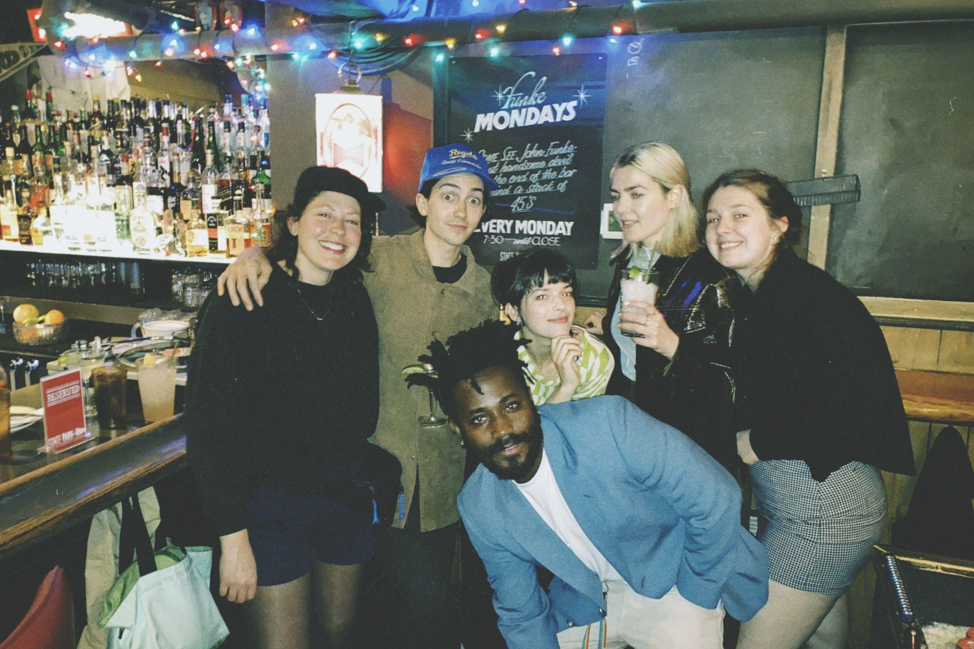
Shane Silverstein (blue hat) is the performing arts programmer at the ICA Boston and once a month spins tracks at State Park. The biotech bros who frequent this bar are not deserving of his curated tunes so we try to get the art crowd to take over when Shane is behind the deck. On this particular night I was introduced to a drink the bartender referred to as a "Somerville Sunset." It's Miller High Life with Campari poured directly into the bottle and it might just give the Dirty Shirley a run for its money this summer.

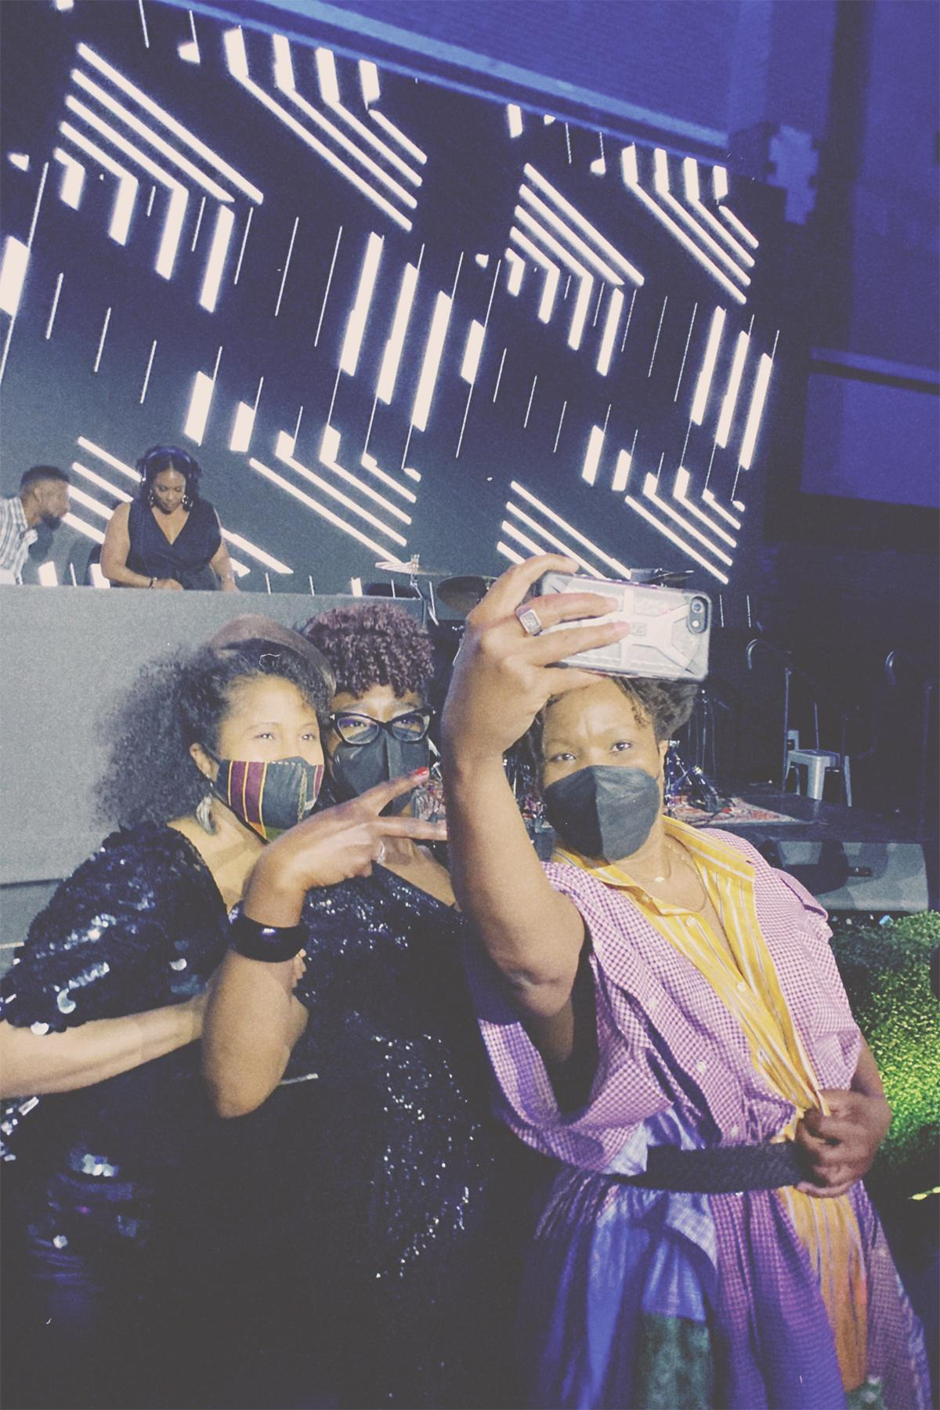
As you can tell from the previous photos, the Boston art scene is not glamorous or sceney, but on this particular weekend, I had the honor of attending the ICA's 2022 Gala and the even bigger honor of dancing the night away with artist Dell Marie Hamilton (left), professor Nikki Green (middle) and artist Tomashi Jackson (right). Yes, Tomashi is rocking a handmade garment made from dress shirts.

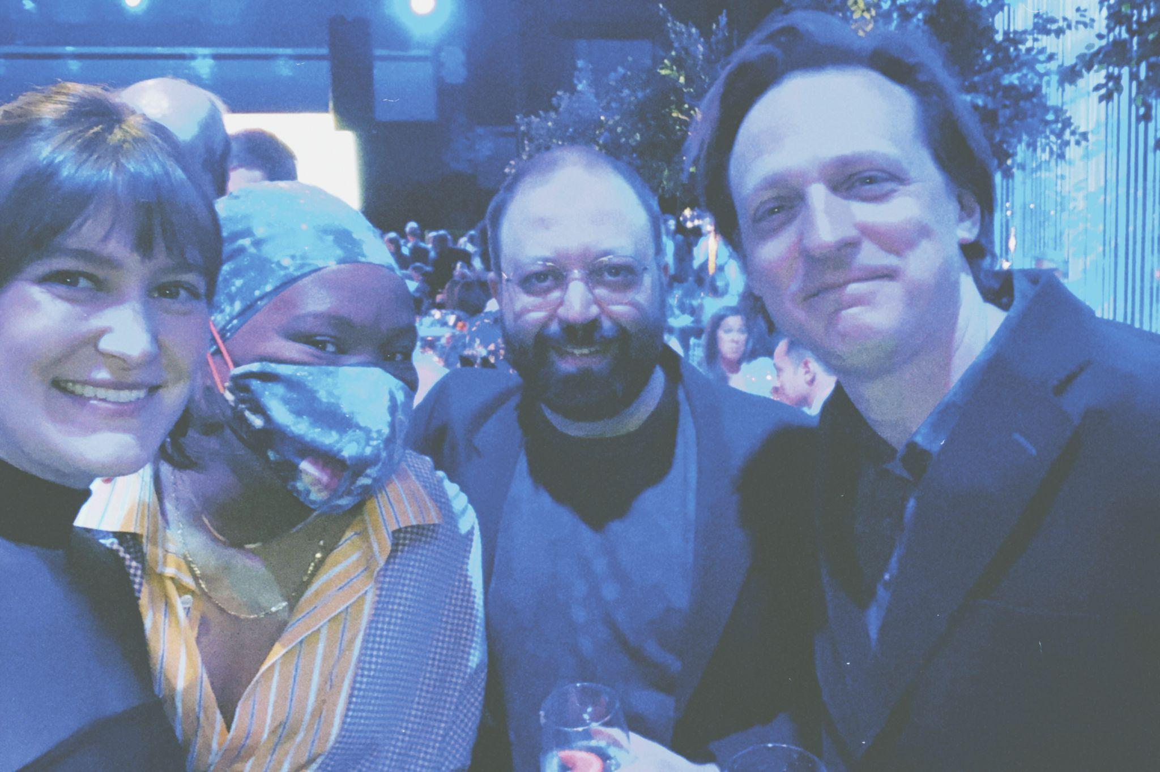
I was instructed that selfies are required for Wet Paint so here’s our attempt. I’m on the left next to artist Tomashi Jackson, director of Harvard’s Carpenter Center Dan Byers is in the center, and artist Matt Saunders is on the right. The theme for the night was “bringing Venice to Boston” in honor of the ICA’s presentation of work by Simone Leigh in Venice. Naturally, I was handed an Aperol spritz and a cicchetti upon entering.
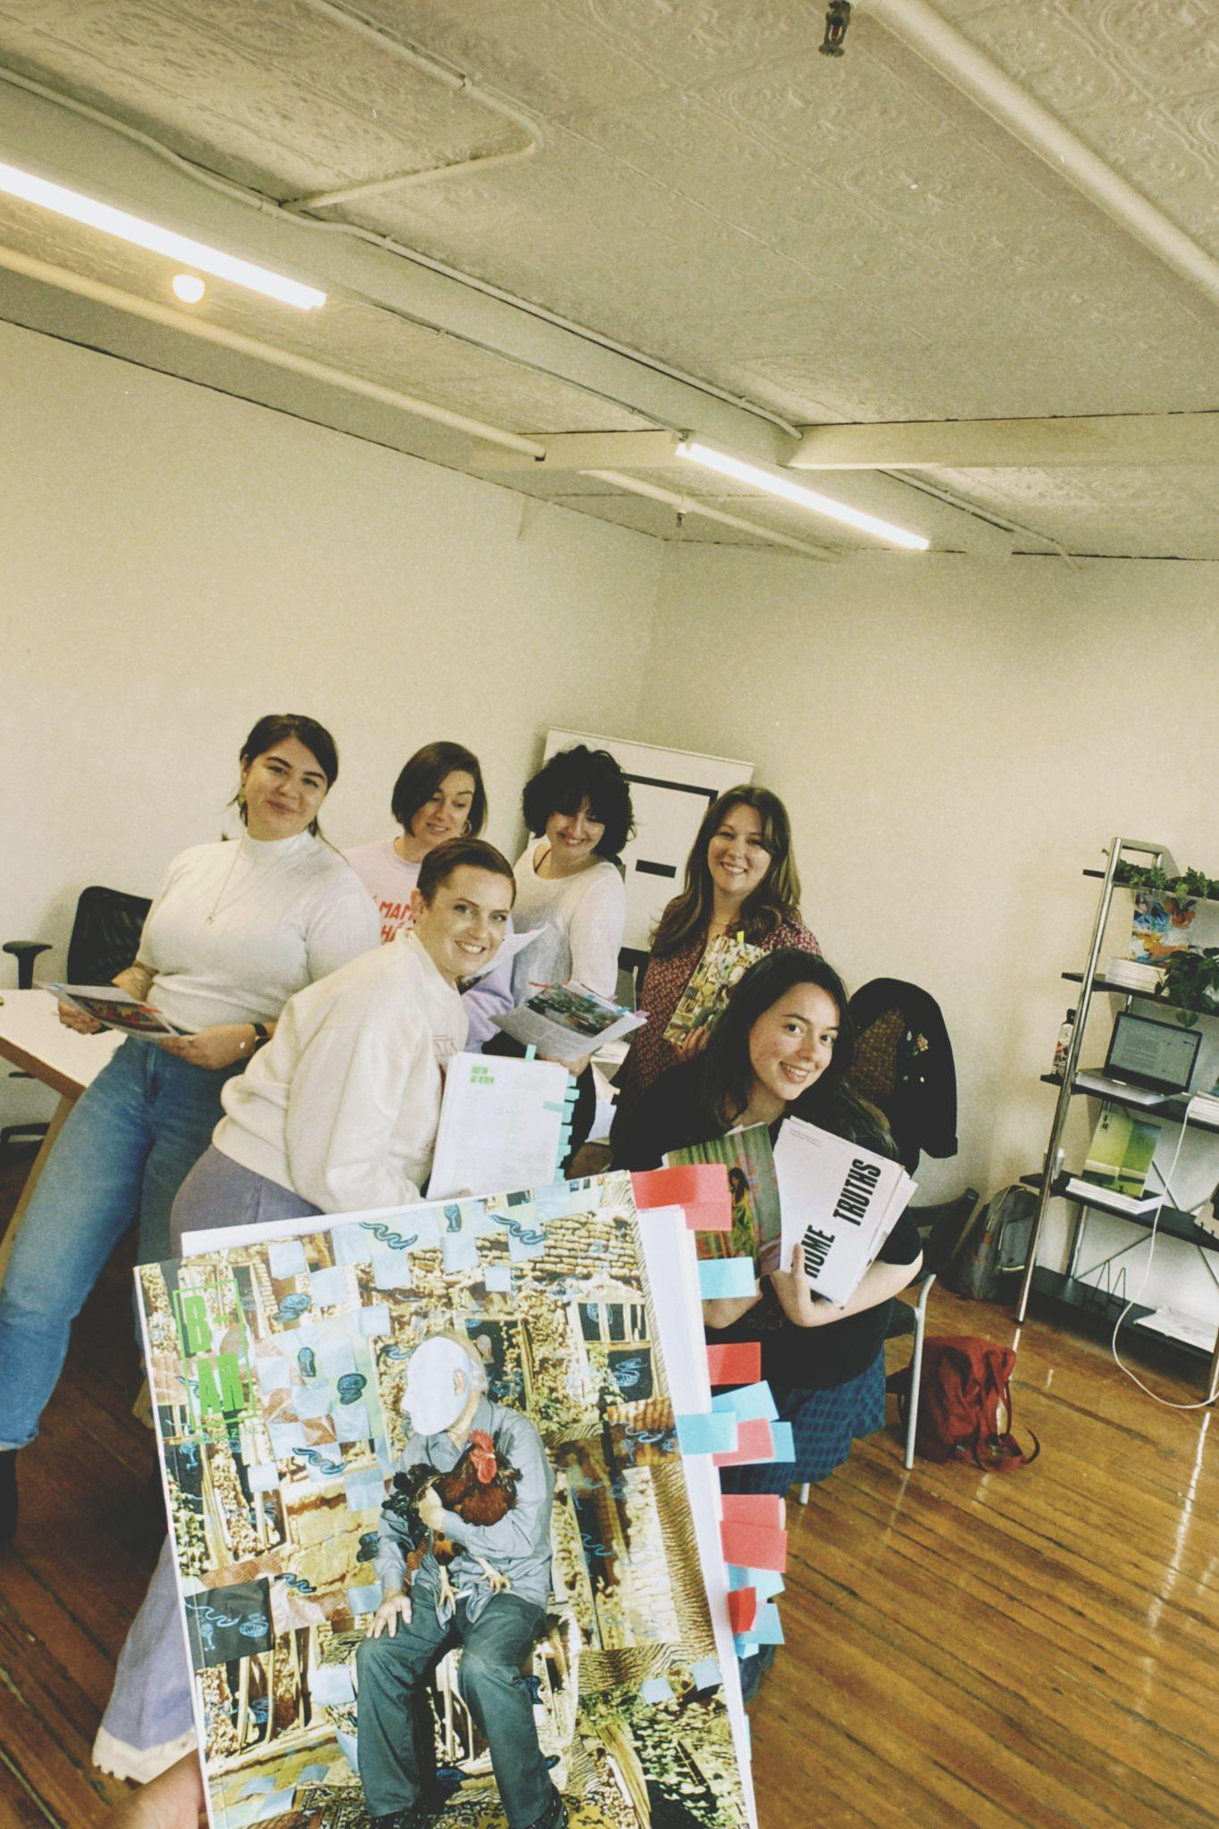
Staying up late wasn't an option because by Saturday morning I was hard at work reviewing the proof for Boston Art Review's eighth issue, Face to Face with some members of our volunteer editorial team. We just got an office space donated to us at the Boston Center for the Arts which, for a project I started out of a coffee shop, feels completely surreal. Issue 08 is available on May 21st at our launch party and features work by Providence-based artist Sheida Soleimani on our cover.
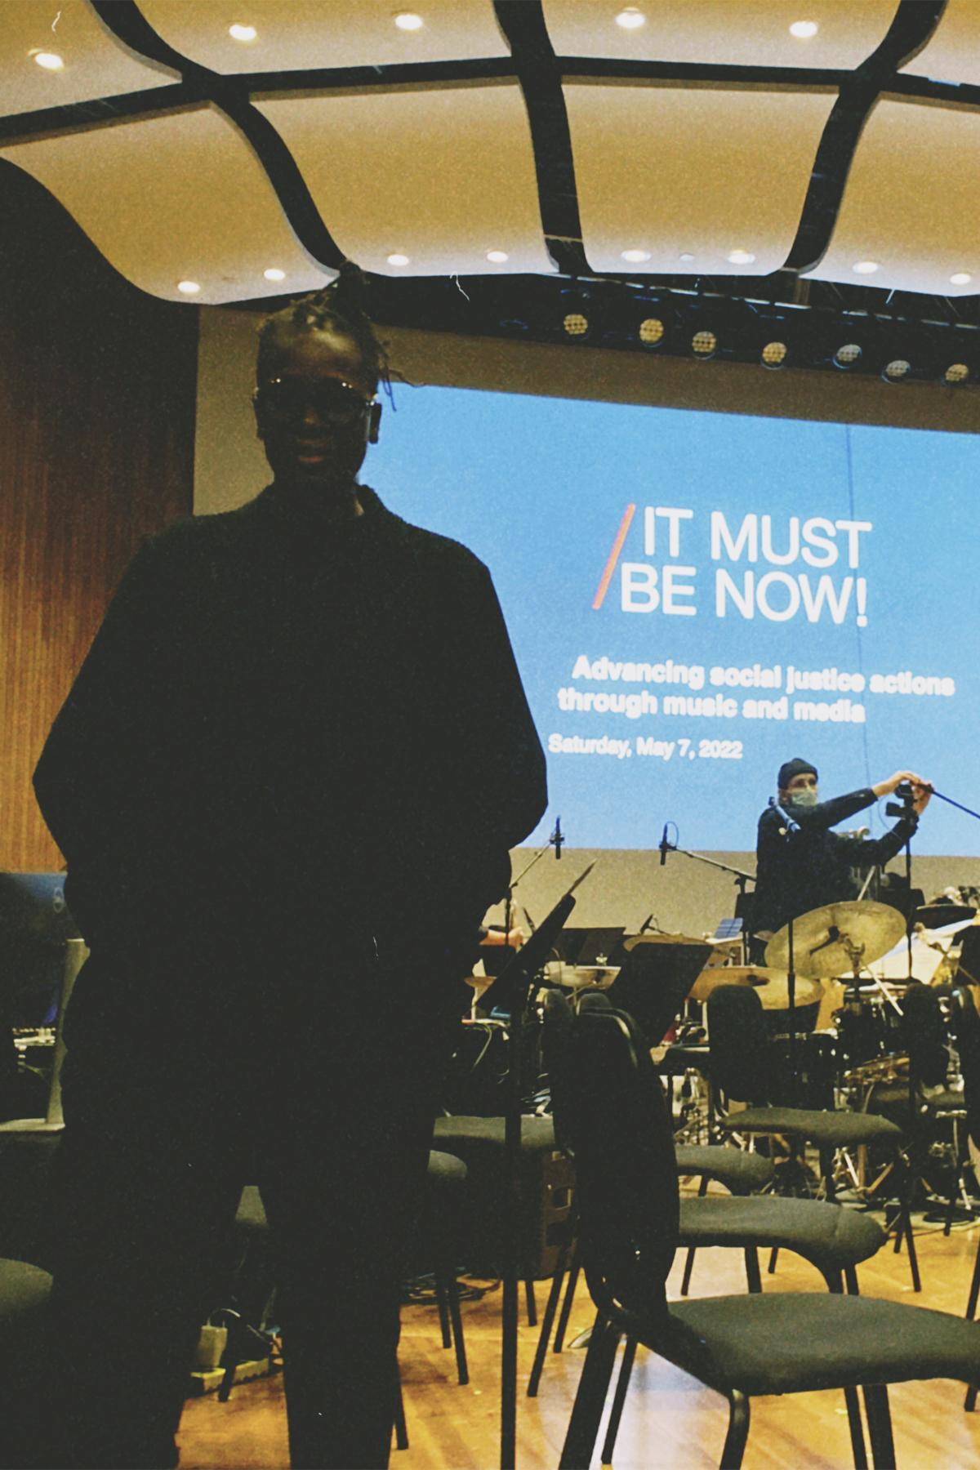
On Saturday night I caught wind of a jazz/dance/spoken word/orchestra performance happening back at MIT where Mickalene Thomas was going to be video DJing. I canceled my plans and snagged a ticket. Caught in the daze after a totally earth shattering performance I forgot to use my flash when grabbing a picture of Mickalene.

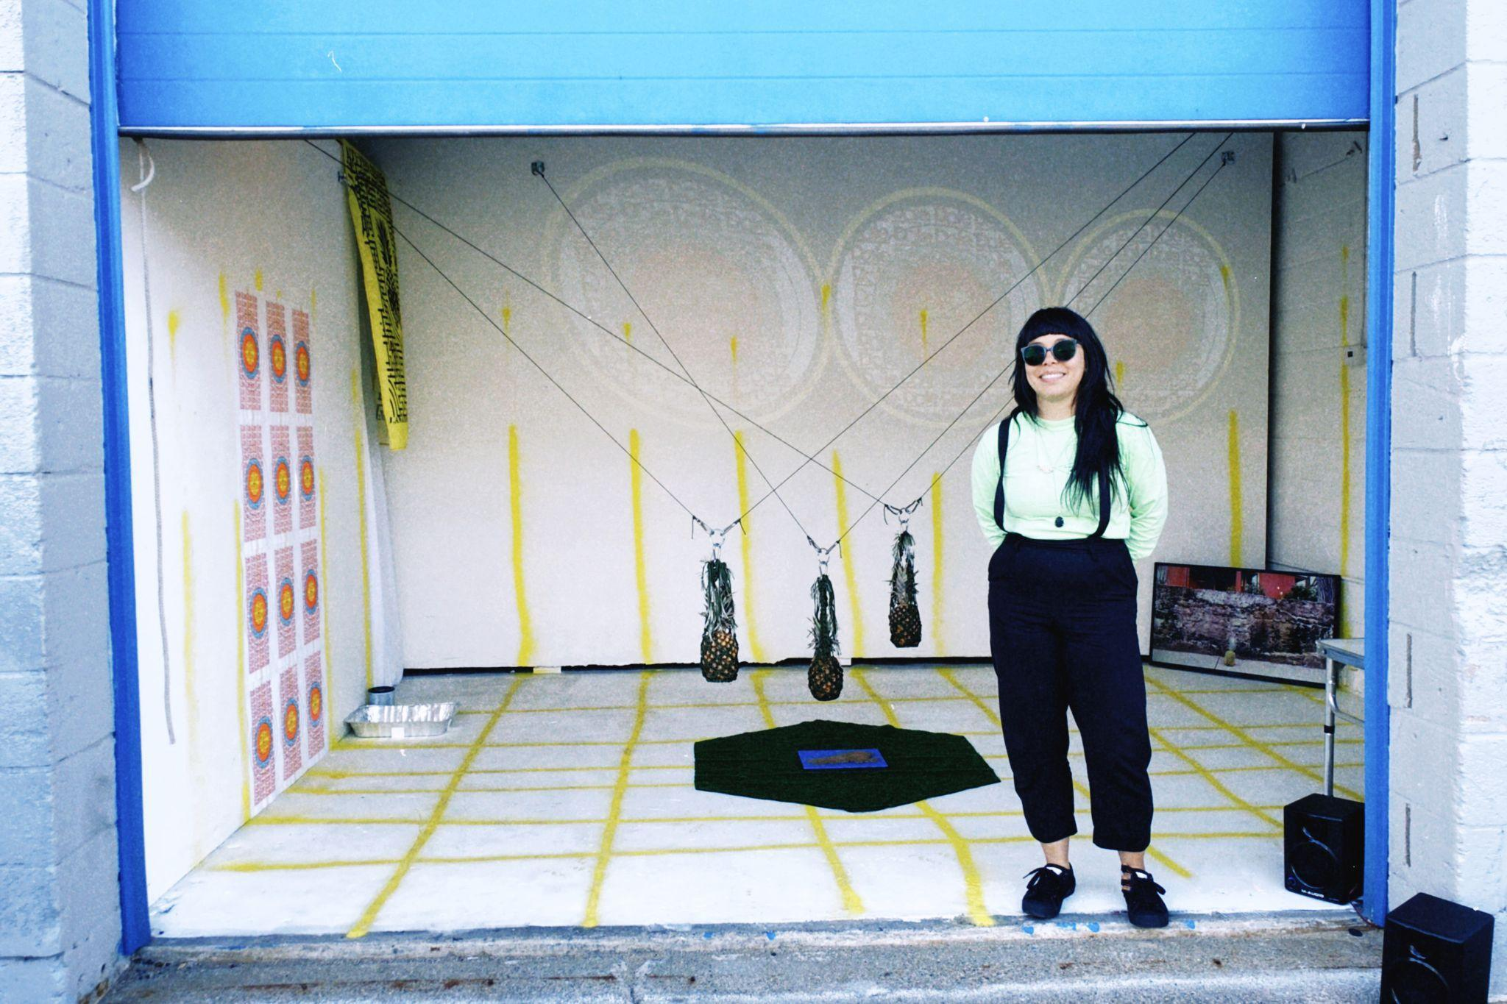
Sunday afternoon, I stopped by a new artist-run space in Jamaica Plain called 10b where my friend and Boston-based artist, Lani Asuncion was performing. Space is a huge issue in Boston so I always applaud folks who are trying to make it work wherever they can, which in this case, is in the garage behind a car wash.

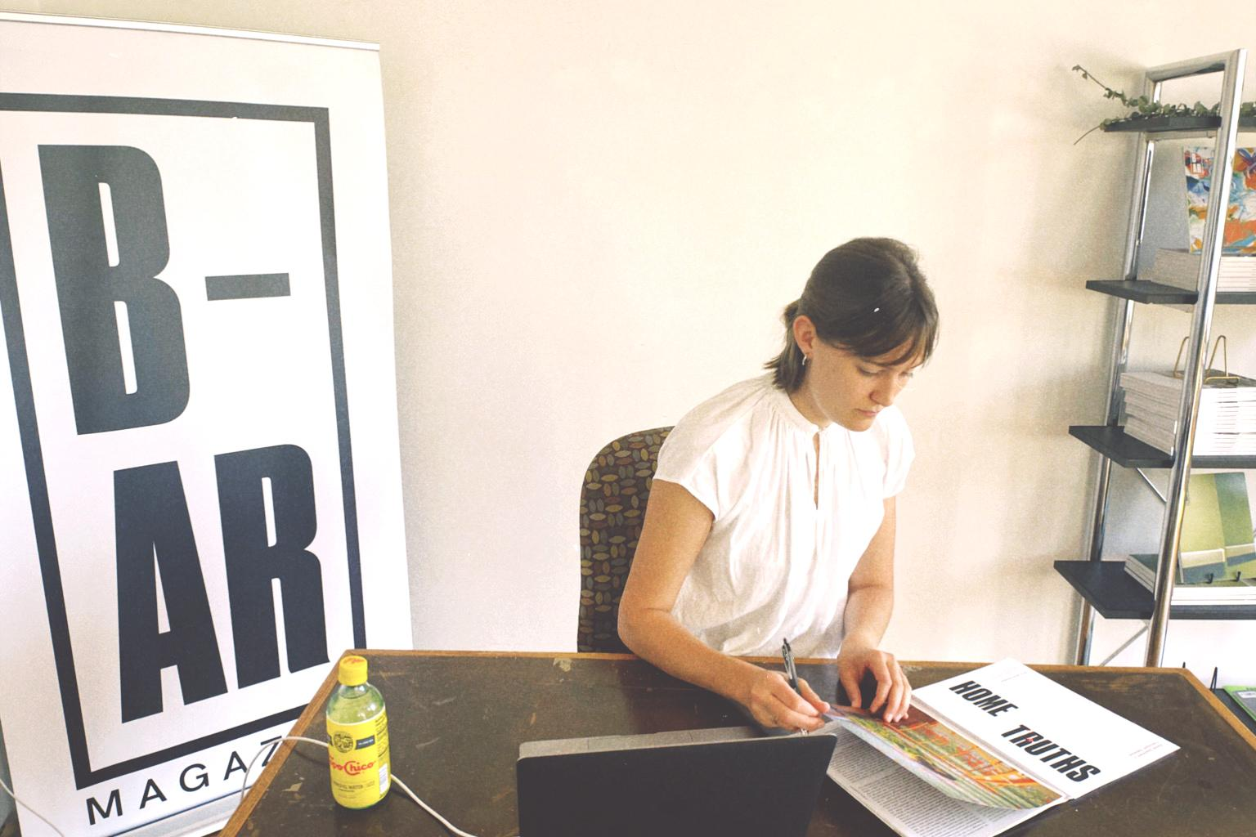
So concludes my week of making Boston look cool (just kidding, that’s my job all the time.) Someone once told me if you want to make a small fortune in publishing you need to start with a large one. I don’t have a fortune, but I do have an incredible community—many of whom are not pictured in this abnormal week of parties— and that is definitely worth more than money can buy. Stick around Boston long enough and you might just join the regulars table.

Bio:
Jameson Johnson is editor in chief at Boston Art Review—a publication she founded in 2017 that recently became a nonprofit organization. She is also the communications and development manager at the MIT List Visual Arts Center.

